**Introduction To Databases**

**Problem Statement:** There can be multiple customers, who can place multiple orders on the

site. Now a sales person can handle these orders will distribute into multiple sales persons (One

order will be assign to one salesperson only). So a sales person can have multiple orders of

multiple customers.

1) Create Database



2) Design Schema

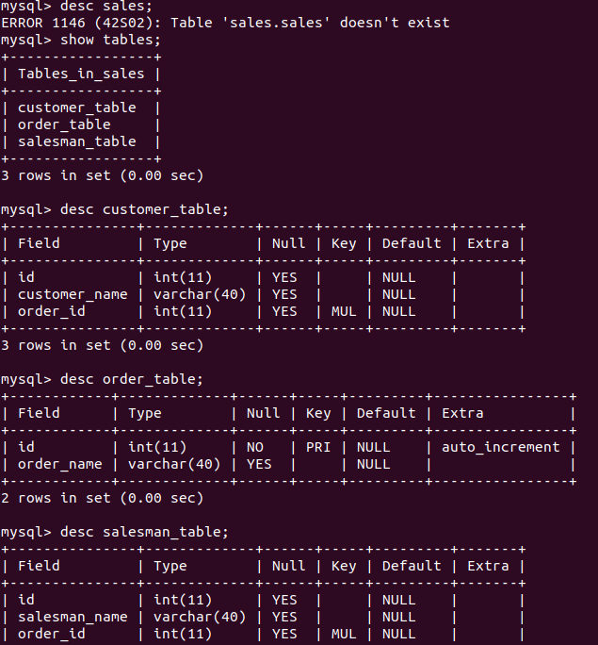

3)Create tables

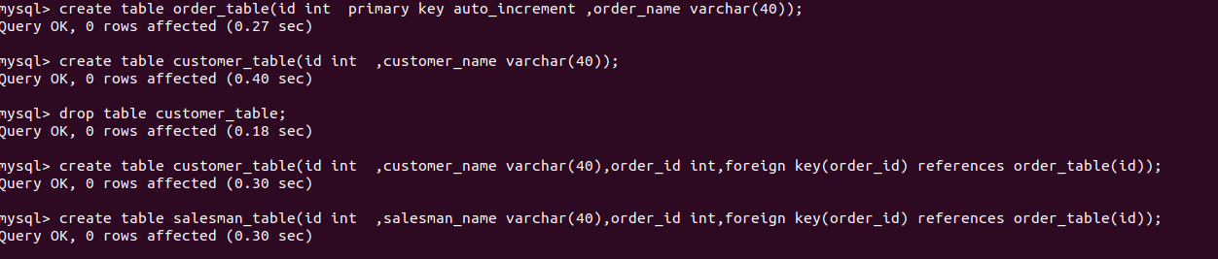

4) Insert sample data

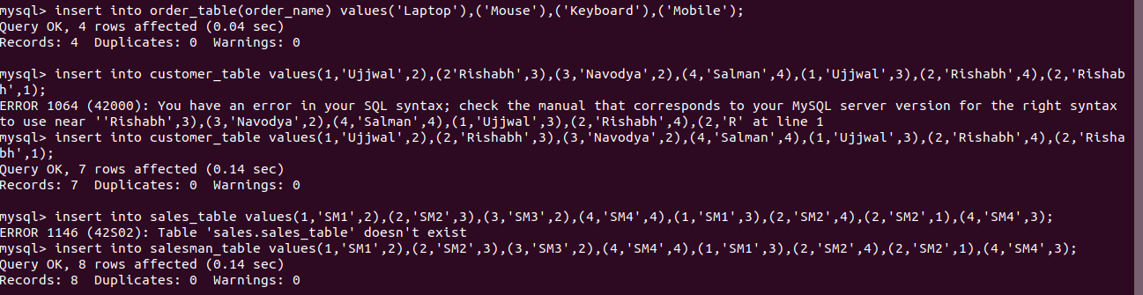

5) Find the sales person have multiple orders.

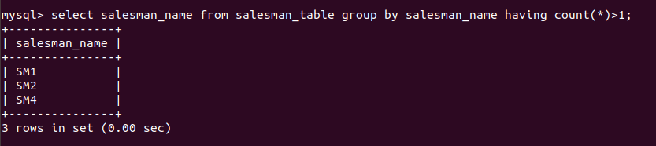

6) Find the all sales person details along with order details

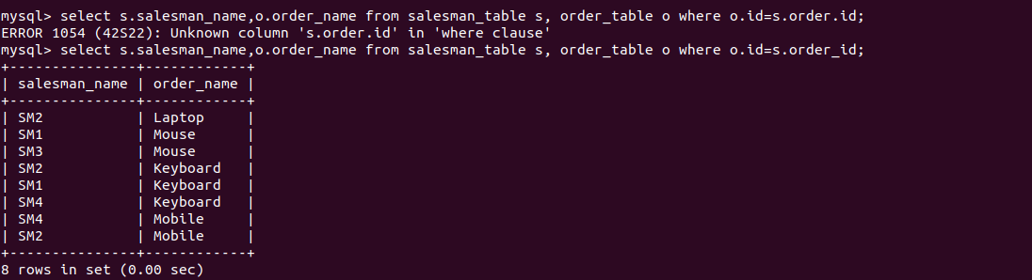

7) Create index



8) How to show index on a table

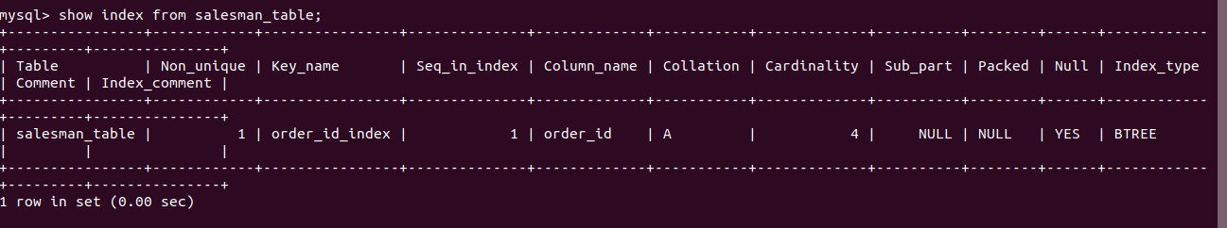

9) Find the order number, sale person name, along with the customer to whom that order belongs to

